**INFORMATION**

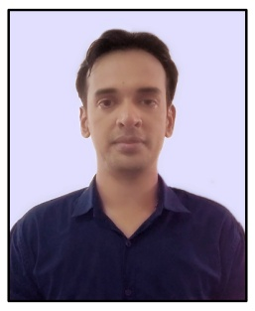

**NAME: Kundan Singh Shahi**

**PASSPORT SIZE PIC:**

**Highest Qualification: M.A, 1 Year Diploma in Computer HW& Networking**

**Designation: Lab Technician**

**LAB No. Assigned: DF-05 (D Block)**

**Email Id: kundanshahi.cse@jecrc.ac.in**

**Experience: 10 Years**